Fast Food Analysis & Data Cleaning Using Power BI
Transforming Raw Data into Actionable Insights
Client:
Fast Food Business / Nutrition Analytics
Project Type:
Data Analytics & Data Cleaning Project
Tools & Technologies Used:
Microsoft Power BI (Power Query)
SQL
Objective:
To clean, standardize, and prepare fast food nutrition data to ensure accuracy, consistency, and readiness for dashboard reporting and analytical insights.
Prepared By:
• Dhrumil Pitaliya
• Shivam Dadhich
• Anand Prajapati
• Yash Nayak
Date:
January 2026

Power BI Data Cleaning & Transformation Methodology
This document provides a comprehensive and professional explanation of the complete data cleaning and transformation workflow implemented in Power BI using Power Query. The objective of this documentation is to ensure transparency, data reliability, and clear communication of analytical decisions made during the preparation of the dataset for client reporting and dashboard development.

Step 1: Establishing Data Source Connection
- Purpose of the Step:
To import raw nutritional data into Power BI and initiate the analytical workflow.
- Transformation Performed:
Connected to the source system and loaded the relevant dataset into Power Query Editor.
- Power Query Evidence:
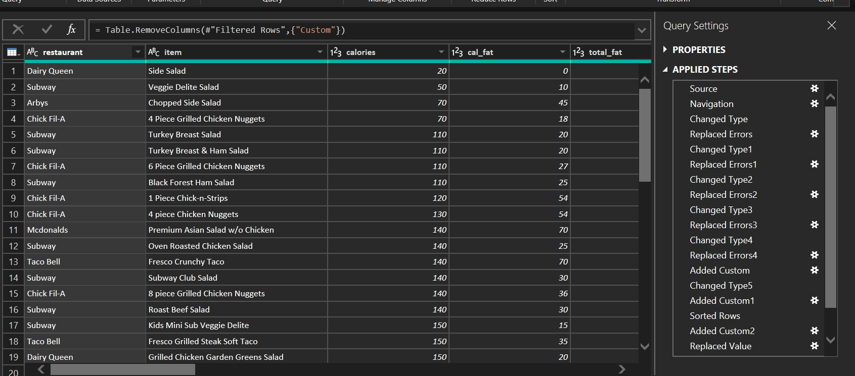

Step 2: Navigating to the Relevant Dataset
- Purpose of the Step:
To isolate the required table and avoid unnecessary data processing.
- Transformation Performed:
Selected the appropriate table from the data source navigation pane.
- Power Query Evidence:
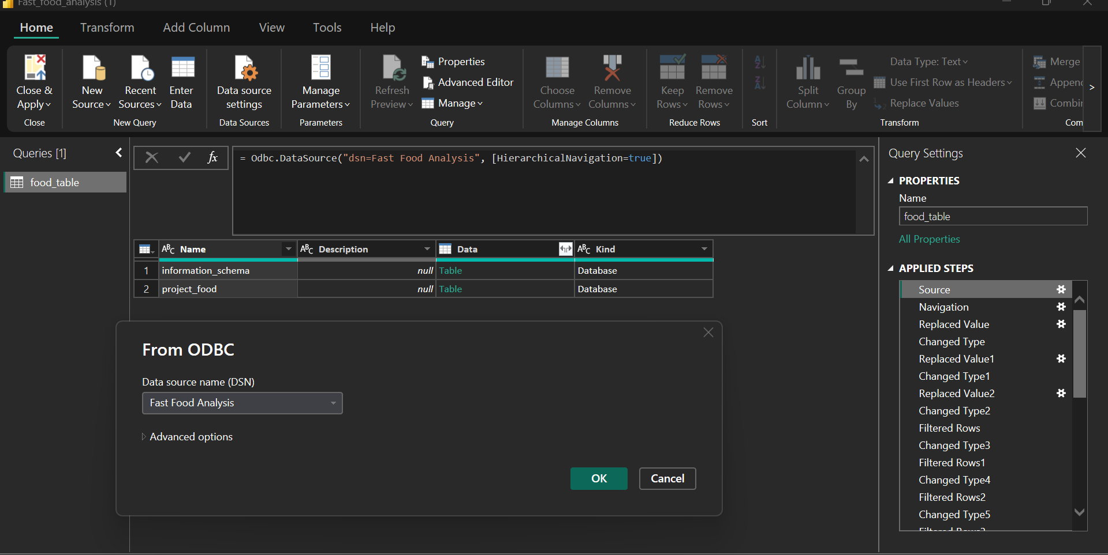

Step 3: Initial Data Type Standardization
- Purpose of the Step:
Incorrect data types can lead to calculation errors and inaccurate insights.
- Transformation Performed:
Converted columns such as calories, fats, vitamins, and minerals into appropriate numeric formats.
- Power Query Evidence:
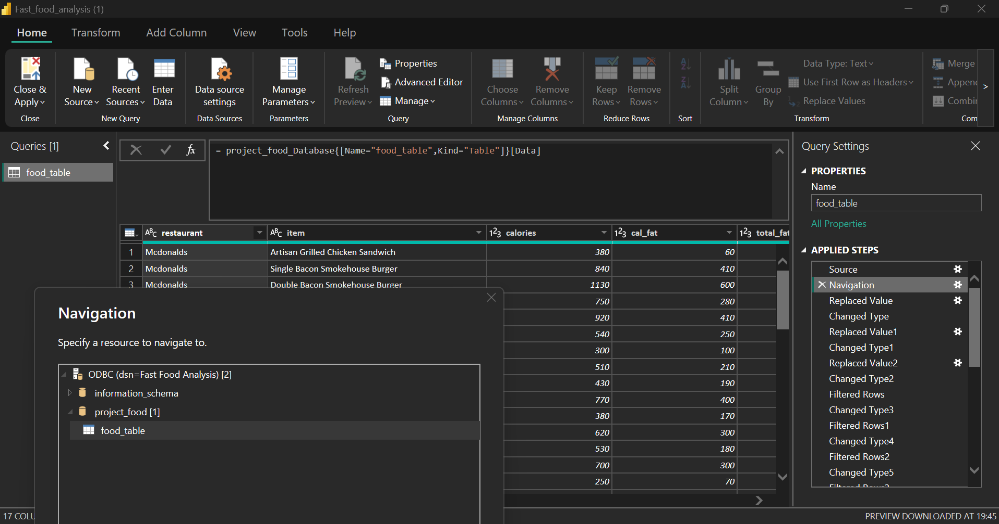

Step 4: Secondary Data Type Validation
- Purpose of the Step:
Some columns still retained text formatting after initial conversion.
- Transformation Performed:
Performed additional data type corrections to ensure full numerical consistency.
- Power Query Evidence:
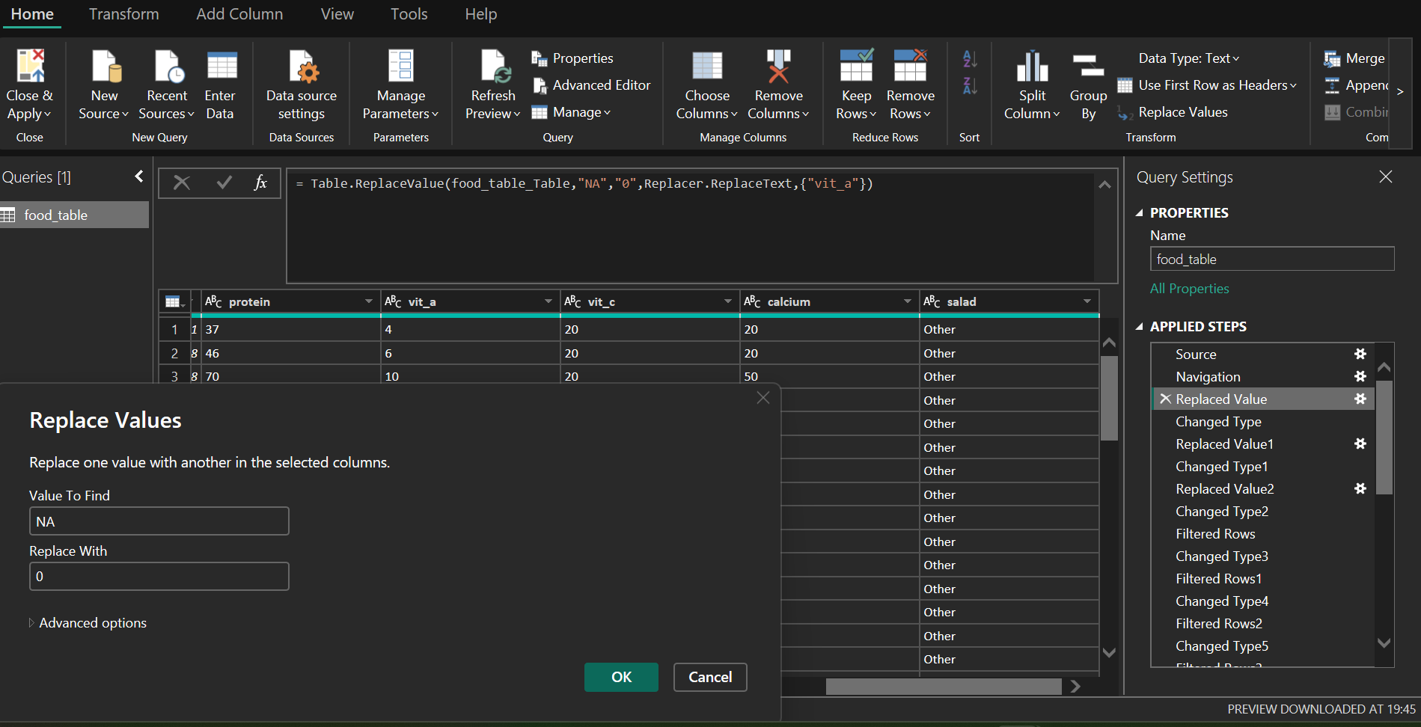

Step 5: Handling Missing Nutritional Values
- Purpose of the Step:
Null values negatively impact aggregations and health metrics.
- Transformation Performed:
Replaced missing vitamin and calcium values with standardized defaults.
- Power Query Evidence:
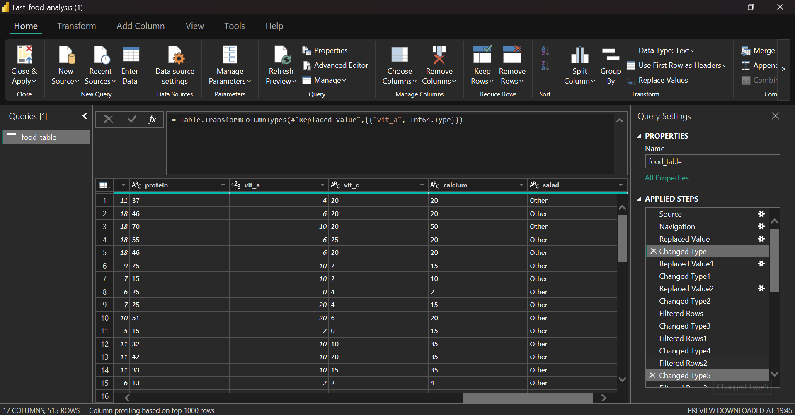

Step 6: Advanced Null Handling and Validation
- Purpose of the Step:
Ensures uniformity across all nutrition-related fields.
- Transformation Performed:
Validated replacements and corrected remaining inconsistencies.
- Power Query Evidence:
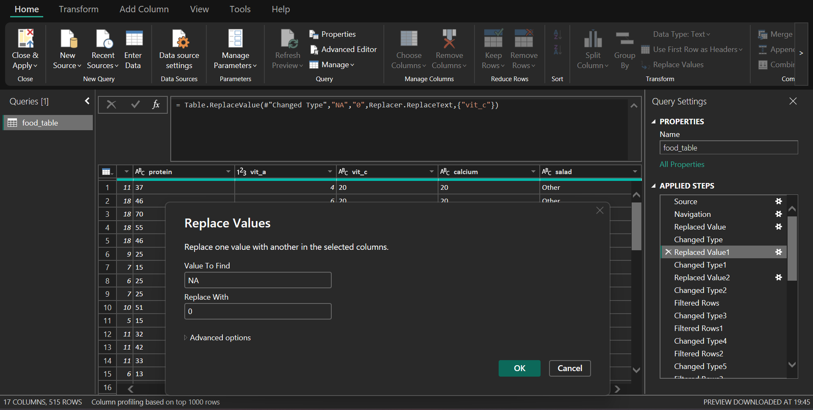

Step 7: Filtering Invalid Fiber Records
- Purpose of the Step:
Zero or negative fiber values are not nutritionally meaningful.
- Transformation Performed:
Filtered rows to retain only records with valid fiber values.
- Power Query Evidence:

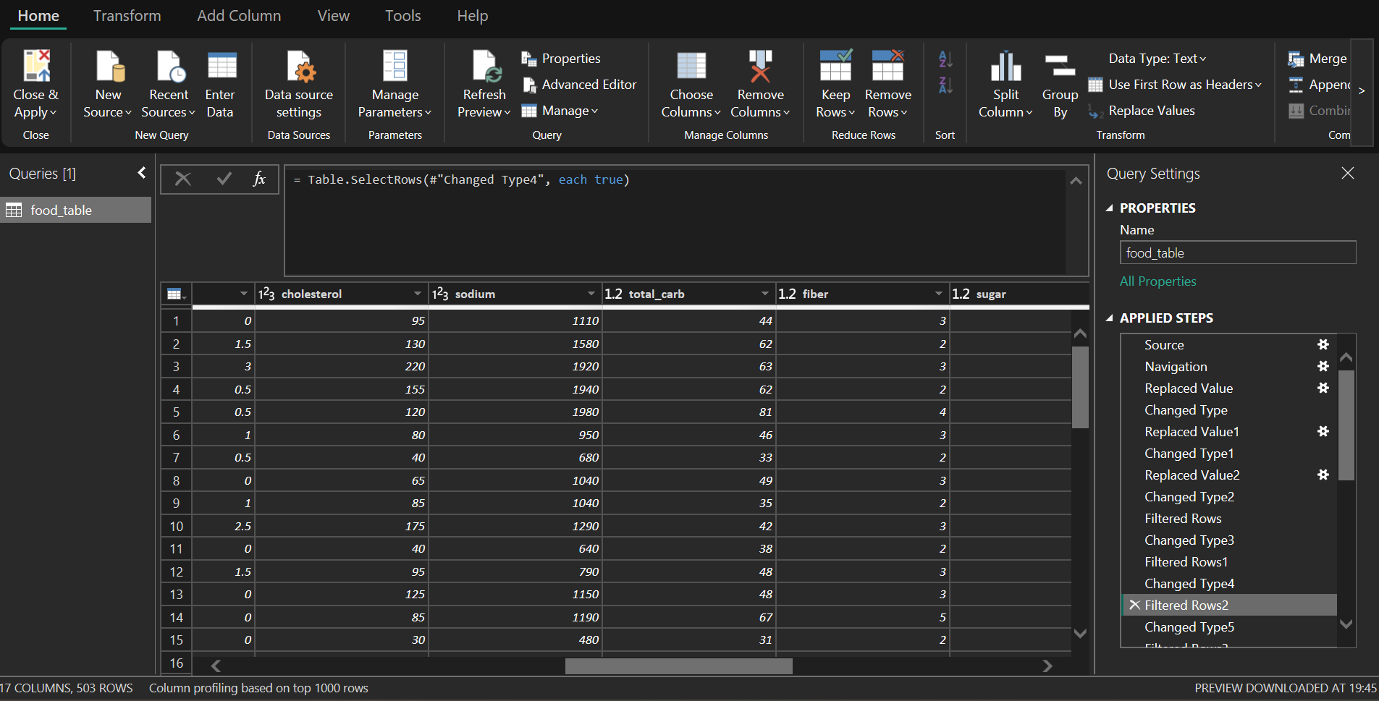

Step 8: Filtering Invalid Sugar Records
- Purpose of the Step:
Sugar metrics must be accurate to support health classification.
- Transformation Performed:
Removed rows with invalid or zero sugar values.
- Power Query Evidence:
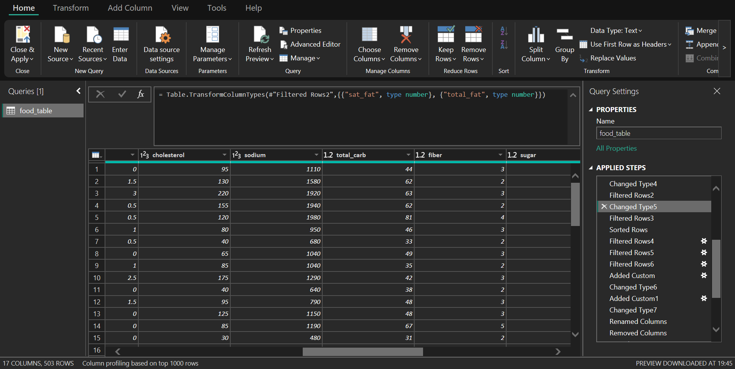

Step 9: Sorting Based on Fat Contribution
- Purpose of the Step:
Sorting enables identification of high-fat food items quickly.
- Transformation Performed:
Sorted dataset using fat-related nutritional indicators.
- Power Query Evidence:
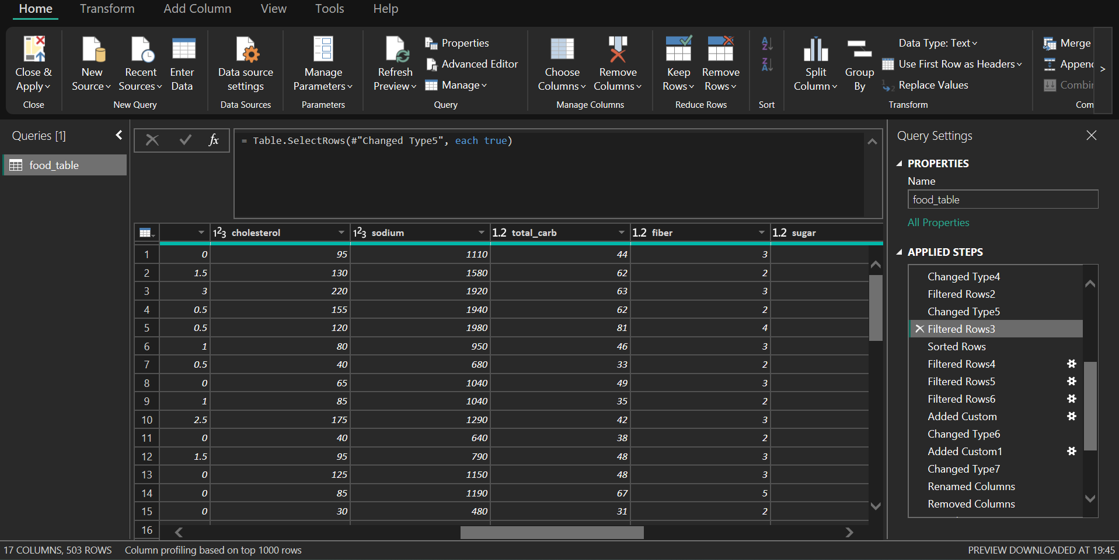

Step 10: Custom Metric Development – Fat Calories Percentage
- Purpose of the Step:
To quantify the proportion of calories derived from fat.
- Transformation Performed:
Created a calculated column using the formula (Fat Calories ÷ Total Calories).
- Power Query Evidence:
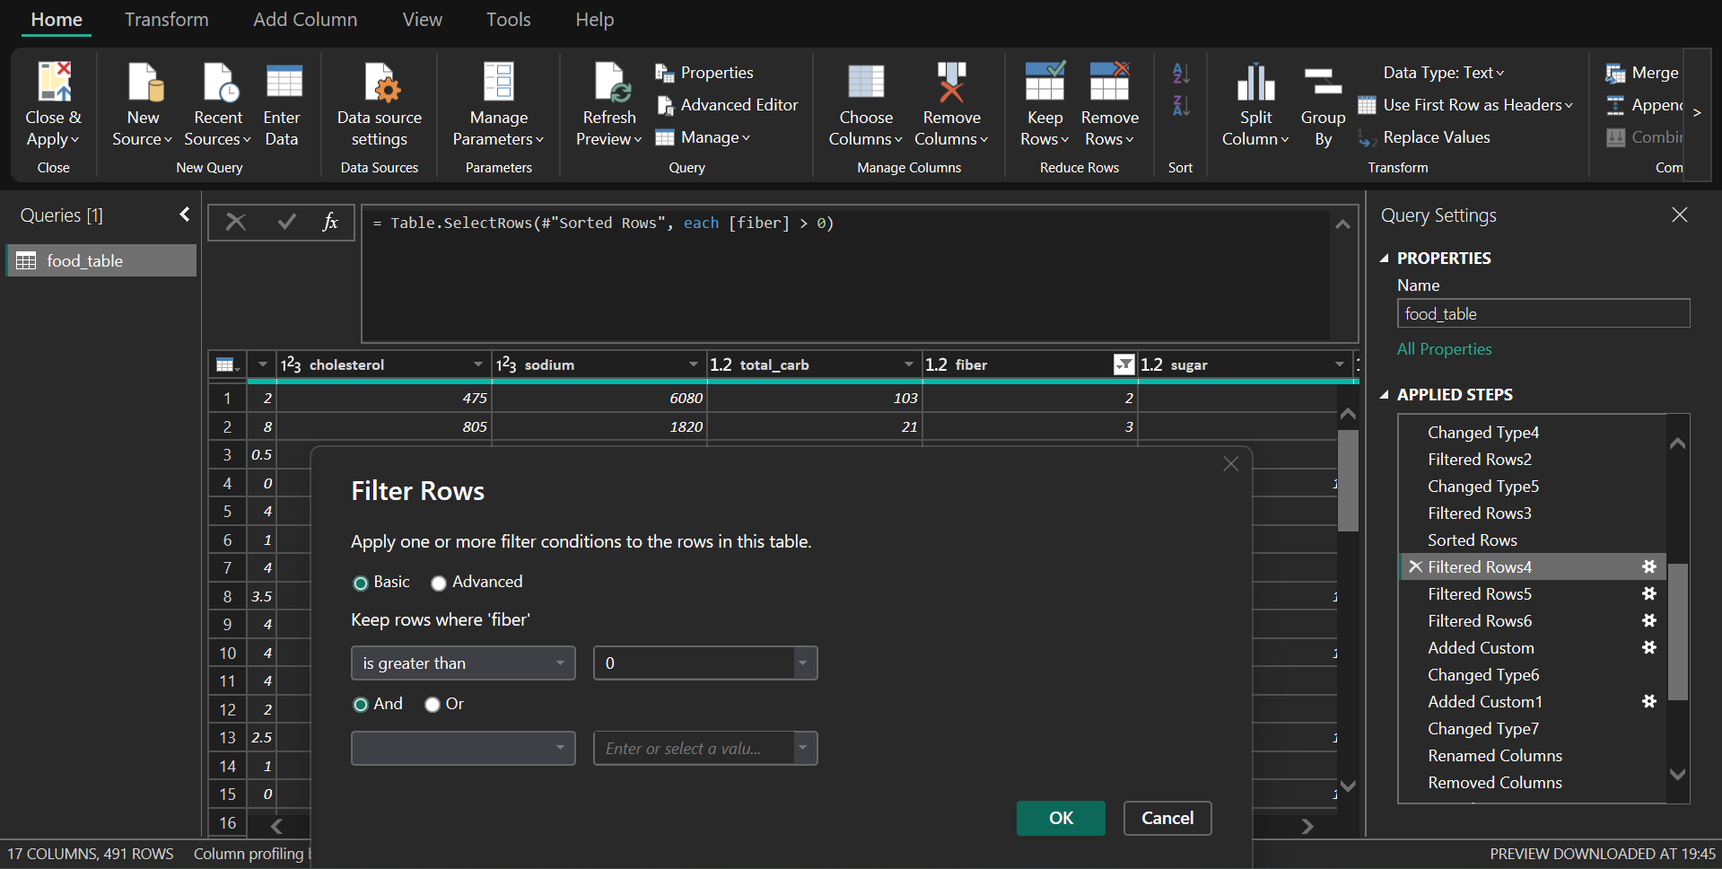

Step 11: Formatting Calculated Metrics
- Purpose of the Step:
Improves interpretability and reporting consistency.
- Transformation Performed:
Formatted the calculated fat calories column as a percentage.
- Power Query Evidence:
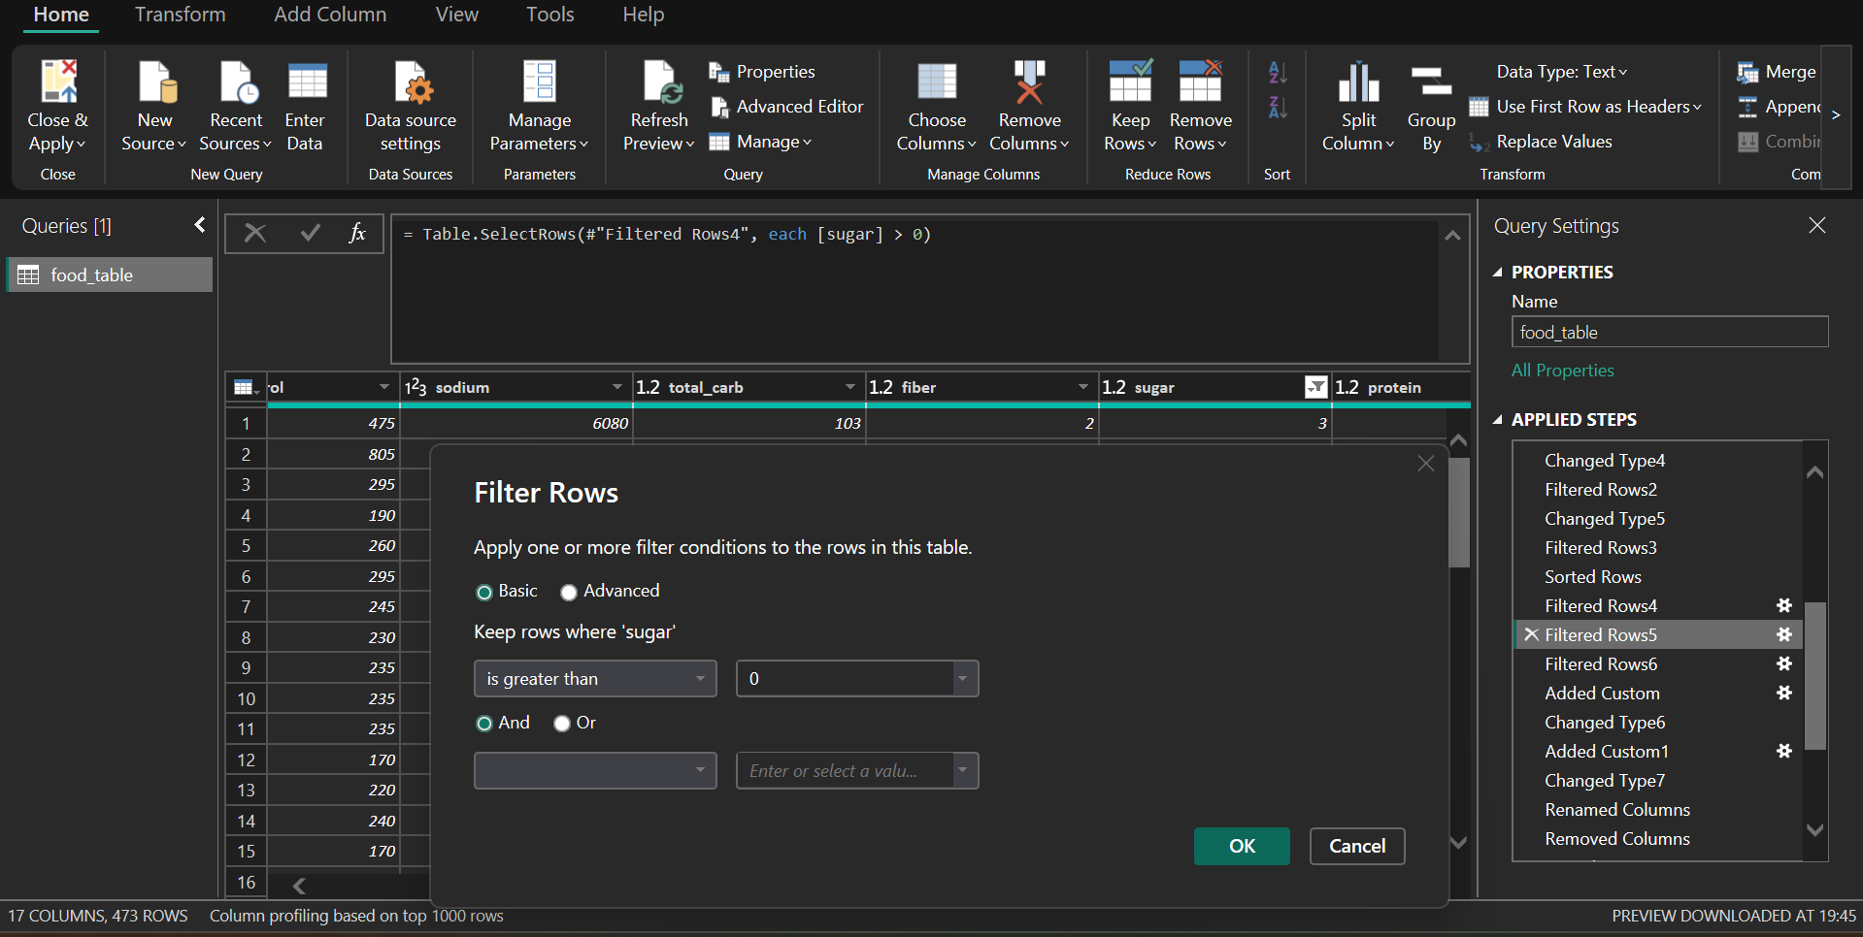

Step 12: Removing Temporary and Helper Columns
- Purpose of the Step:
Intermediate columns are not required for final analysis.
- Transformation Performed:
Removed redundant columns to streamline the dataset.
- Power Query Evidence:
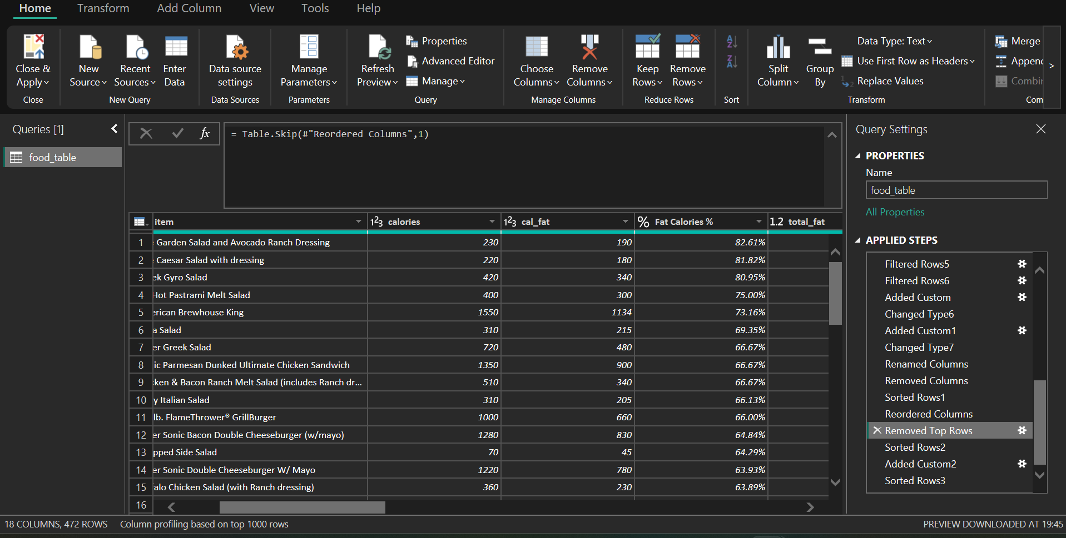

Step 13: Column Reordering for Analytical Clarity
- Purpose of the Step:
Logical column sequencing improves usability and readability.
- Transformation Performed:
Reordered columns to align with reporting and dashboard needs.
- Power Query Evidence:

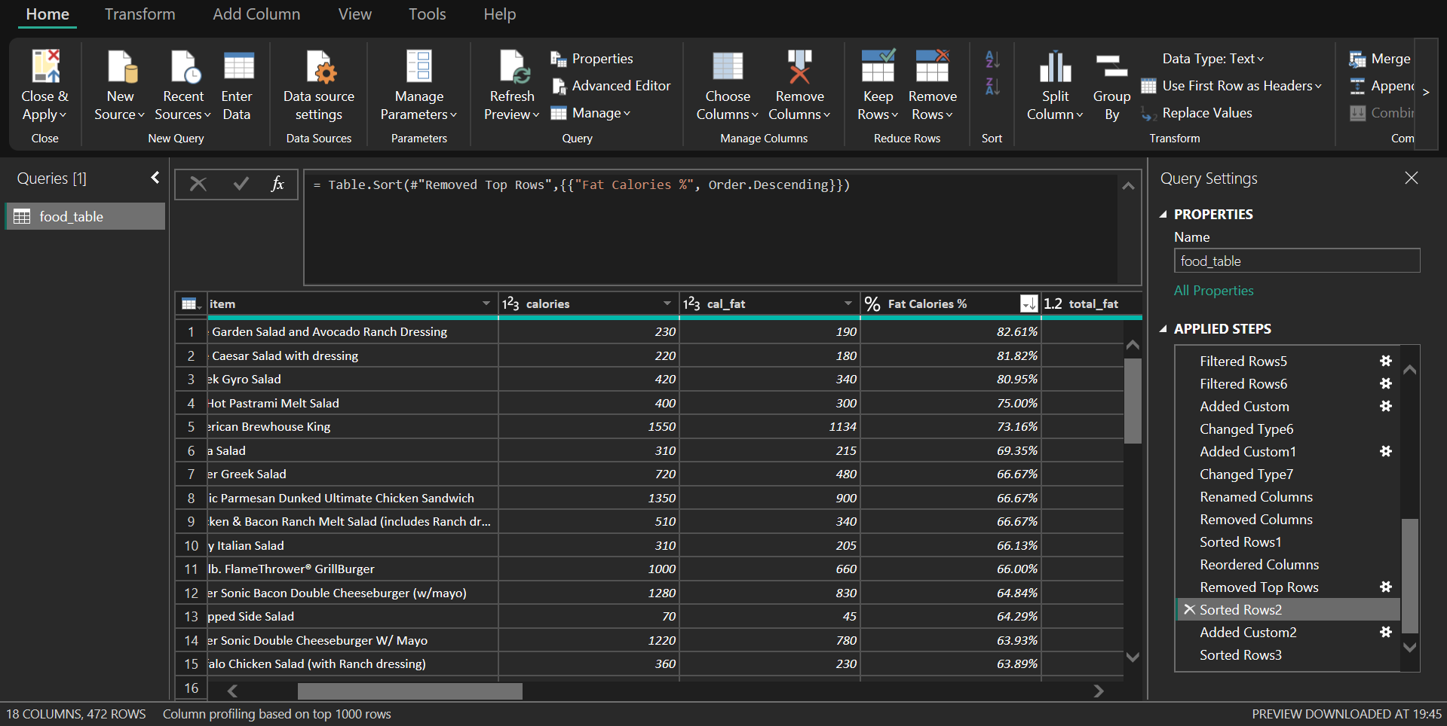

Step 14: Health Category Classification Logic

- Purpose of the Step:
To enable health-based segmentation of food items.
- Transformation Performed:
Classified records into Healthy, Moderate, and Unhealthy categories using Fat Calories %.
- Power Query Evidence:
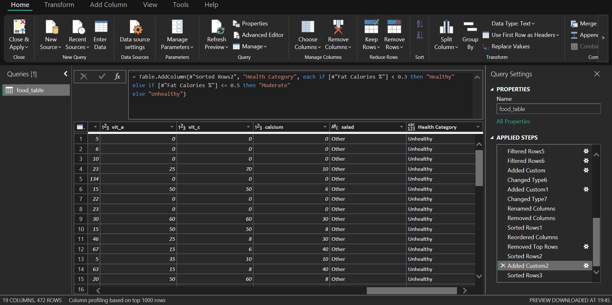

Step 15: Final Validation and Sorting

- Purpose of the Step:
Ensures readiness of the dataset for dashboard deployment.
- Transformation Performed:
Performed final sorting and validation of transformed data.
- Power Query Evidence:
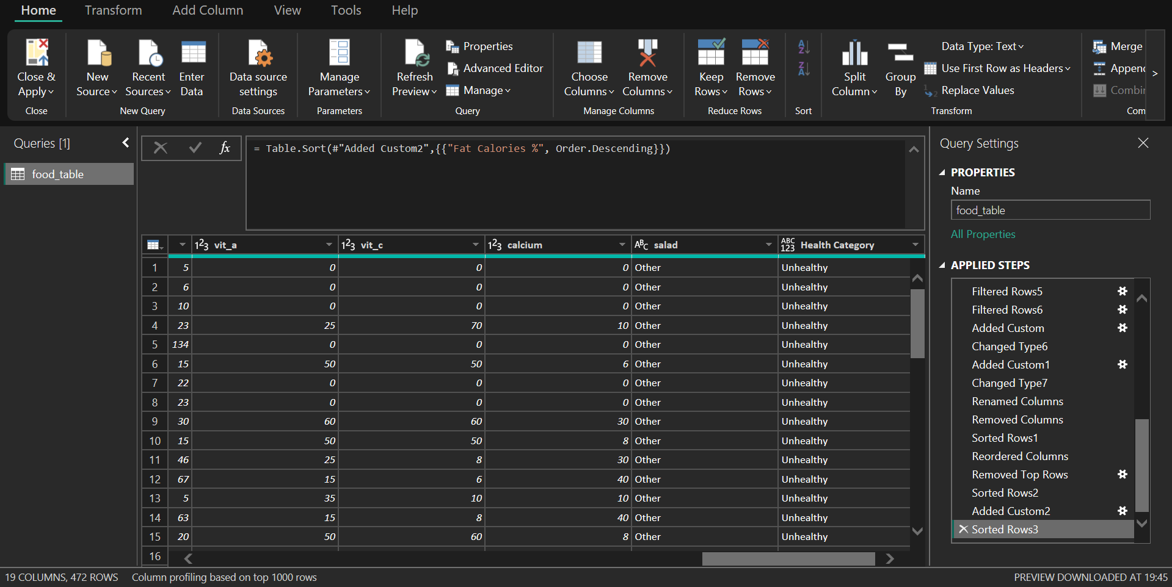

Conclusion and Data Readiness Confirmation
The above Power Query workflow demonstrates a structured, auditable, and best-practice-driven approach to data preparation. All transformations were executed with a clear analytical purpose, ensuring that the final dataset is accurate, consistent, and suitable for executive-level dashboards and client decision-making.

